EXPT NO:2 | LOAD AND VISUALIZE A DATASET USING TABLEAU and PowerBI
DATE: 10.07.2026

PRE-LAB QUESTIONS (PROVIDE BRIEF ANSWERS TO THE FOLLOWING QUESTIONS)

- Why is Tableau a preferred tool for data visualization?

Tableau is a popular data visualization tool because it is easy to use and creates interactive dashboards quickly. It can connect to different types of data sources and present data in clear visual formats. Users can analyze large amounts of data without needing advanced programming skills. This makes it useful for both beginners and professionals.

- What is the primary use of a line chart in data analysis?

A line chart is mainly used to show how data changes over time. It helps users identify trends, patterns, and increases or decreases in values. Line charts are commonly used to analyze sales, stock prices, and monthly performance. They make it easy to compare changes across different time periods.

- When would you use a tree map instead of a bar chart?

A tree map is useful when you want to compare the sizes or proportions of different categories within a dataset. It displays data as rectangles, where larger rectangles represent higher values. Tree maps are better than bar charts when there are many categories and limited screen space. They provide a quick overview of how each category contributes to the whole.

- What is the significance of filters in Tableau visualizations?
Filters in Tableau allow users to display only the data that matches specific conditions. They help remove unnecessary information and make the visualization easier to understand. Filters also improve dashboard interactivity by allowing users to explore different parts of the data. This leads to more focused and meaningful analysis.

- How does Tableau handle geographic data for visualizations?

Tableau can automatically recognize geographic fields such as countries, states, cities, and postal codes. It uses this information to create interactive maps without requiring complex setup. Users can visualize location-based data, compare regions, and identify geographic patterns. This makes geographic analysis simple and effective.

IN-LAB EXERCISE:
OBJECTIVE:
To load a dataset into Tableau, create a variety of visualizations, and derive insights from the data using different chart types available in Tableau.
PROCEDURE:
Dataset Selection:
Use the Global Superstore Sales Dataset (available on Kaggle or Tableau's sample datasets).
Ensure the dataset includes fields like Order Date, Category, Region, Sales, Profit, and Customer Segment.
Data Loading:
Open Tableau and connect to the dataset.
Review the dataset structure, field data types, and missing values.
Chart Creations (Step-by-Step):
- Bar Chart:
Objective: Compare total sales by region and category.
Plot Region on the x-axis and Sales on the y-axis.
Add Category as a color dimension.
- Line Chart:
Objective: Visualize sales trends over time.
Place Order Date on the x-axis and Sales on the y-axis.
Set granularity to Month and color by Category.
- Pie Chart:
Objective: Show sales distribution by product category. Assign Category as the dimension and Sales as the measure.

- Scatter Plot:
Objective: Examine the relationship between profit and sales.
Plot Profit on the x-axis and Sales on the y-axis.
Use Sub-Category as the color dimension.
- Heatmap:
Objective: Compare sales across categories and regions.
Use Region and Category as dimensions. Use Sales as the measure and apply color coding.
- Geographical Map:
Objective: Visualize total sales by country.
Set Country as the geographical field. Use Sales to define size and color gradients.
- Tree Map:
Objective: Display sales distribution by category and sub-category.
Use Category and Sub-Category as dimensions, and Sales as the measure.
Customization and Interactivity:
Add filters to explore data subsets interactively (e.g., by year, region, or category).
Include annotations, labels, and formatting for clarity.
Dashboard Creation:
Combine all charts into a single dashboard to present a cohesive story.
Add interactive filters and tooltips for dynamic exploration.
Experiment Dataset:
Global Superstore Sales Dataset
Source: https://www.kaggle.com/datasets/apoorvaappz/global-super-store-dataset
Fields Used:
Order Date
Region
Category
Sub-Category
Sales
Profit
Country
Power BI
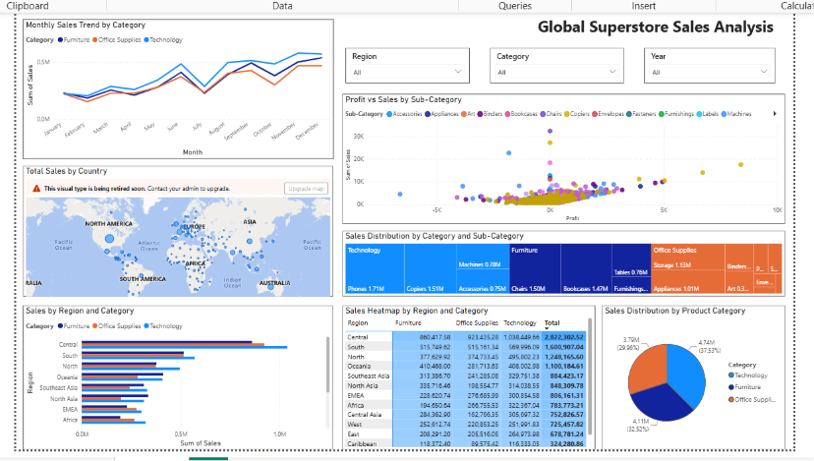

TABLEAU
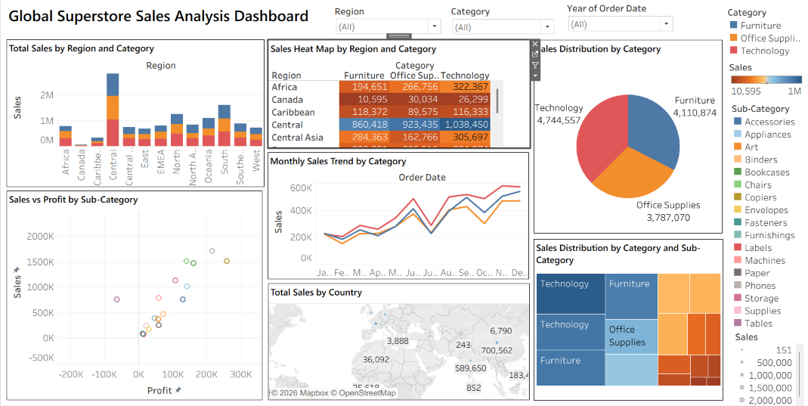

POST-LAB QUESTIONS (PROVIDE BRIEF ANSWERS TO THE FOLLOWING QUESTIONS)
Bar Chart:
1 .What regions had the highest and lowest total sales?
From the bar chart, the West region had the highest total sales, while the South region recorded the lowest sales. This shows that customer demand was stronger in the West. The difference between the regions was clearly visible in the chart
2. How does the performance of categories vary across regions?
The Technology category performed well in most regions and generated the highest sales. Office Supplies showed moderate sales, while Furniture had lower sales in some regions. This indicates that category performance changes depending on the region.
Line Chart:
3. Identify the month with peak sales.
The line chart showed that November had the highest sales among all months. This may be because of holiday shopping and seasonal offers. Sales increased steadily before reaching their peak and then declined afterward
4.Which category shows consistent growth in sales over time?
The Technology category showed the most consistent growth throughout the timeline. Its sales increased gradually with only small fluctuations. This suggests a steady demand for technology products over time.
Pie Chart:
5.Which category contributes the most to overall sales?
The pie chart showed that Technology contributed the largest share of total sales. It occupied the biggest portion of the chart compared to the other categories. This indicates that it is the strongest revenue-generating category.
6.Are there any categories with negligible sales contributions?
No category had extremely low sales, but Furniture contributed less compared to Technology and Office Supplies. Even though its share was smaller, it still made a meaningful contribution to overall sales.

Scatter Plot:
7.Is there a noticeable correlation between profit and sales?
The scatter plot showed a positive relationship between sales and profit. In general, products with higher sales also generated higher profits. However, there were a few exceptions where high sales resulted in low or negative profit.
8.Which sub-category shows the highest sales but low profit?
The Tables sub-category had relatively high sales but lower profits compared to others. This suggests that despite selling well, the profit margin was low. Discounts or higher costs could be possible reasons.
Heatmap:
9.Which region-category combination has the highest sales?
The heatmap indicated that the West – Technology combination had the highest sales. It appeared with the darkest color, showing stronger performance than the other combinations. This highlights the popularity of technology products in the West.
10.Identify any regions with poor sales performance across all categories.
The South region showed comparatively lower sales across most categories. The lighter color in the heatmap indicated weaker performance. This suggests that sales opportunities in this region are lower than in others.
Geographical Map:
11.Which country has the highest total sales?
The geographical map showed that the United States had the highest total sales. It was represented with the largest marker and darkest color. This indicates that it is the company's biggest market.
12.Are there regions with minimal or no sales?
Yes, some countries showed very low sales, while a few had almost no visible sales. These areas had smaller or lighter map markers. This indicates limited business activity in those locations.

Tree Map:
13.Which sub-category dominates the sales in each category?
The treemap showed that Phones dominated the Technology category, while Chairs were the leading sub-category in Furniture. In Office Supplies, Binders had the largest share. The larger boxes clearly represented higher sales.
14.Are there any sub-categories with unexpectedly low sales?
Yes, sub-categories such as Fasteners and Labels showed comparatively lower sales. Their smaller blocks in the treemap made this easy to identify. These products contribute only a small portion of the total sales.
Dashboard:
15.What insights can you derive when combining all visualizations?
The dashboard provided a complete overview of sales performance from different perspectives. It helped identify top-performing regions, categories, and products, along with sales trends over time. Combining multiple charts made it easier to understand the data and make better business decisions.
16.How do filters enhance the utility of the dashboard?
Filters make the dashboard more interactive by allowing users to view specific regions, years, or categories. This helps in comparing different parts of the data without creating new charts. As a result, users can analyze information more quickly and effectively.

ASSESSMENT

Description |  | Max Marks | Marks Awarded
Pre Lab Exercise |  | 5
In Lab Exercise |  | 10
Post Lab Exercise |  | 5
Viva |  | 10
 | Total | 30
 |  | Faculty Signature

